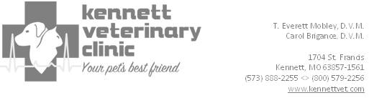
April 19, 2014

To Veterinarians interested in Relief Services:

Subject: Dr. Isaac McKay

I have known Dr. McKay since 1979, when I entered practice about 30 miles away from his practice in Blytheville, Arkansas. We frequently discussed cases, and I often referred orthopedic surgery cases to him.

He had covered my practice for a few 2-week trips in the past. When I expressed to him a desire to take an extended leave from my practice, he agreed to cover it for three and a half months in 2014.

During this time, he was highly productive. I’ve always known he has a great work ethic, and I wasn’t disappointed. I have certainly had other relief doctors who were happy just to keep the door open, and Isaac is not satisfied unless he is working hard and producing at a high level.

In addition to being a hard-working, productive guy, he is also a good diagnostician and surgeon. He stays current with new developments in veterinary medicine.

We send client satisfaction surveys after each visit. Since we offer the client a $5.00 credit for returning them, we get a lot of them back. Dr. McKay received excellent reviews from the clients. He gets along with the staff well, too.

You can trust him with your patients, your clients, and your business. In my book, the measure of a man is whether you can trust his word and his work. You can trust both with Dr. McKay.

Signed,

T. Everett Mobley, D.V.M.

